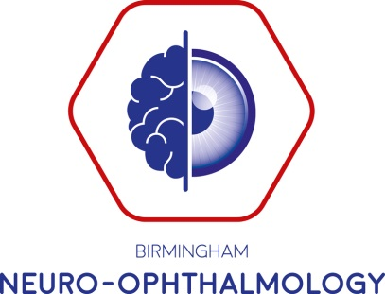

The Birmingham Afferent Course
Wednesday 8th January 2020

Objective: the aim is to review the physiology and the pathology of optic nerve disorders. The course is aimed at ophthalmologists, neurologists and orthoptists of all grades. It will be of value to those preparing for exams or refreshing their neuro-ophthalmology knowledge. The course faculty are recognised experts in this field who will give a comprehensive review and up to date overview of their subjects

Faculty include experts in neuro-ophthalmology, neurology and neuroradiology:
Mr Tim Matthews, Mr Richard Blanch, Mr Mike Burdon, Miss Lidia Alvarez, Mr Andrew Jacks, Professor Alexandra Sinclair, Dr Swarup Chavda, Dr Gordon Mazibrada and Miss Ruchika Batra

Venue: Everyman Cinema, The Mailbox, Birmingham

Provisional Timetable

From 08:30 | Registration
09:00 | Welcome
09:10 | “Doctor...I can’t see” | Ruchika Batra
09:30 | An approach to disc swelling | Mike Burdon
10:00 | Approaching optic neuropathies | Tim Matthews
10:45 | Coffee
11:15 | Ischaemic optic neuropathies | Richard Blanch
11:45 | W5 of neuro-imaging (Who, What, When, Where, & Why) | Swarup Chavda
12:30 | Lunch
13:15 | Inherited optic neuropathies | Lidia Alvarez
13:45 | Optic Neuritis and  Multiple Sclerosis Update | Tim Matthews  Gordon Mazibrada
14:30 | Neuromyelitis optica spectrum disorder | Andrew Jacks
15:00 | Tea
15:30 | Headaches for Ophthalmologists | Prof Alexandra Sinclair
16:00 | Functional Visual Loss | Tim Matthews
16:45 | Questions and close

