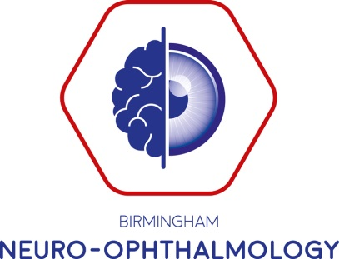

The Birmingham Efferent Course

Wednesday 11th December 2019

Objective: the aim is to review the physiology and the pathology of eye movements. The course is aimed at ophthalmologists, neurologists and orthoptists of all grades. It will be of value to those preparing for exams or refreshing their neuro-ophthalmology knowledge. The course faculty are recognised experts in this field who will give a comprehensive review and up to date overview of their subjects

Faculty include experts in neuro-ophthalmology, orthoptics, neurology and neuroradiology: Mr Mike Burdon, Mr Tim Matthews, Mr Andrew Jacks, Miss Lidia Alvarez, Mr Richard Blanch, Mr James Benzimra, Miss Claire Hazell and Dr Swarup Chavda

Venue: Everyman Cinema, The Mailbox, Birmingham

Provisional Timetable

From 0830 | Registration
0900 | Welcome
0900 | What is double vision? | Mike Burdon
0930 | Causes of double vision and examination of eye movements | Mike Burdon
1000 | Double vision – how to get the most from your orthoptic report | Claire Hazell
1030 | Coffee
1100 | Myasthenia Gravis | Lidia Alvarez
1130 | Brainstem control of eye movements | Tim Matthews
1200 | Lunch
1245 | Supranuclear Disorders of eye movements | Tim Matthews
1330 | W5 of neuro-imaging – Swarup Chavda | Swarup Chavda
1400 | Infranuclear Oculomotility disorders | Richard Blanch and Swarup Chavda
1445 | Tea
1515 | Surgical management of double vision | Andrew Jacks
1600 | Nystagmus | James Benzimra
1630 | Questions and Close

