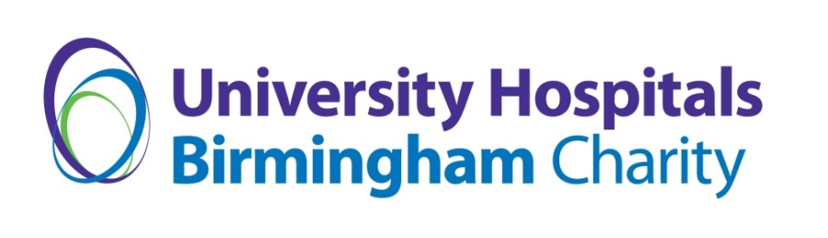
Sprinkle Some Magic Terms & Conditions
- The Sprinkle Some Magic scheme will run from 1 February to 31 October.
- Applications must be for the benefit of patients of University Hospitals Birmingham NHS Foundation Trust.
- All requests must be considered ‘over and above’ what the NHS Trust should be providing as standard.
- Applications must be made to benefit patients as a whole and cannot be for Individual benefit, e.g the purchase of a wheelchair for a named individual.
- UHB Charity will only fund requests that are in line with the Trust’s health and safety and infection control regulations. Any inappropriate requests e.g. alcohol or cash.
- UHB Charity will approve or deny applications within two weeks of confirmed receipt.
- If denied, the Sprinkle Some Magic request can be reviewed and requested from an earmarked ward or department charitable fund.
- Successful applicants must be willing to liaise with the UHB Charity Communications Team to facilitate content for our social media.

