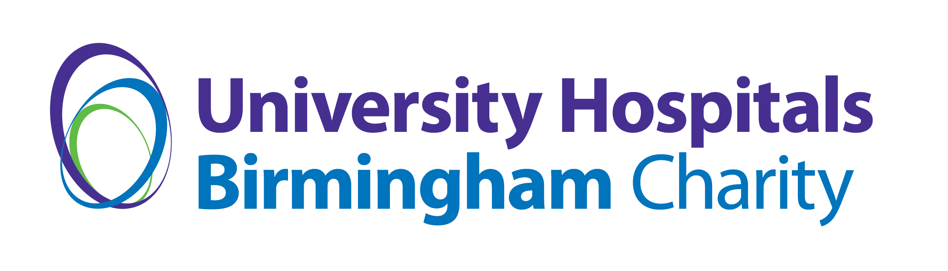
SPRINKLE SOME MAGIC REQUEST FORM
To Sprinkle Some Magic and bring a smile to patients’ faces please complete this one page form and return to charities@uhb.nhs.uk
Your Name:
Your Contact Details (including ward or department name):
What would you like to benefit patients?
(Please also send any website links that explain this further)
What is the total cost of this request?
If you are not asking the hospital charity for all the money needed, where is the rest of the money coming from?

Why can’t the NHS fund this?

How will be hospital charity be recognised for its support?

