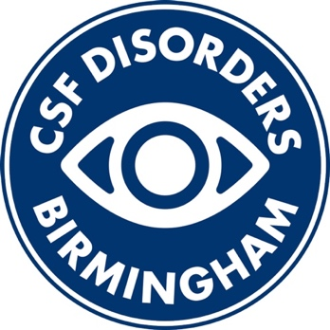
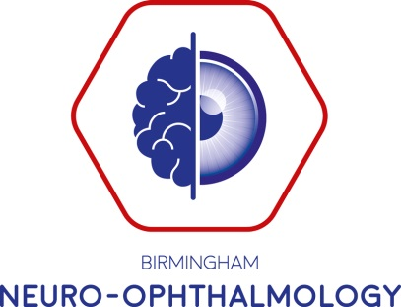

UK CSF Day
Monday 4th July 2022
Edgbaston Park Hotel, University of Birmingham
0845 | Registration and Coffee
0900 | Welcome
0905  (1hr 25min) | Case Presentations and Trainee Prizes  Nurse Forum (Breakout room)
1030  (15 mins) | Coffee break
1045  (45 mins) | Getting Ahead - update on advances in headache
1130  (1 hour) | Keynote Speaker
1230 | Lunch
1315  (30 mins) | Debate – This house believes stenting is the best for treatment of Idiopathic Intracranial hypertension
1400  (30 mins) | Update on trials in CSF disorders
1430  (30 mins) | Hot topics under pressure:  - Waveform analysis/ICP  - Optimal shunt valve settings in IIH vs NP Hydrocephalus
1500 | Coffee break
1530  (30 mins) | Radiology – what’s important in CSF disorders
1600  (25 mins each workshop, select by lunch on sheets. Places limited for practical) | Workshops (chose 2)  - Direct ophthalmoscope training (model eyes)  - How I follow up IIH in clinic?  - How do I get the best OCT (& importance of adjusting segmentation)?  - How do I get the most accurate visual field result?  - OCT case-based discussion in CSF  - What is medication overuse, and how to advise?  - Triptan triple therapy, how to advise?
1700 | Questions and meeting close

